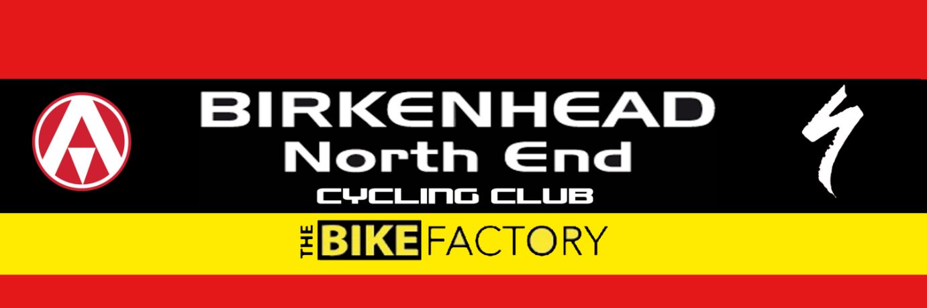

Open Hilly 22 mile Time Trial
Course D22/1

Friday 15th April 2021
(Promoted for and on behalf of Cycling Time Trials under their Rules & Regulations)

Event Secretary: Dave Simmons, mobile – 07920543919 or 07973803021 email – Dasimmons77@gmail.com

Dear Riders,
Many thanks for attending our annual Hilly 22 Time Trial in the lovely Cheshire Countryside.
Luckily we where blessed with warm weather for this time of year as well as Cows crossing the road. Apologies to all riders effected by this, unfortunately this is certainly something I wasn’t able to mitigate.
What appeared to be a still day at HQ turned into something a bit more challenging out on the course however some very good times were posted.
The Marshal’s tried their best to keep everyone safe and motivated and appreciated your thank-yous on route.
Well done to all the winners on the day and I shall e-mail you to see if you require a cheque or direct payment to your account.
Both myself and all at BNECC hope to see you next year.
Kind regards
Dave Simmons.

